- For the same problem we solved in Project#1, compute the trajectory for 10 periods at ∆t = P/1000 using the fourth-order Runge-Kutta algorithm and T4.

Both Independently:

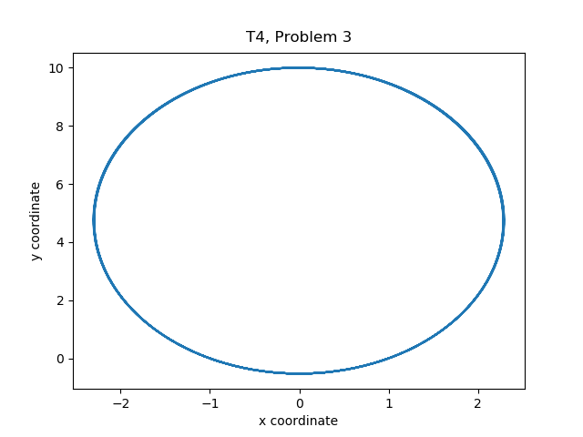
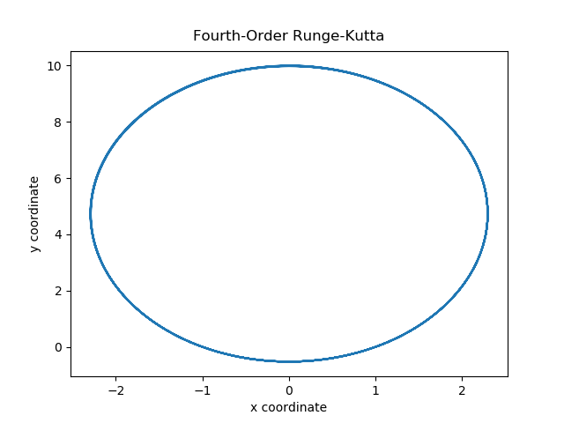
Both Trajectories overlayed:
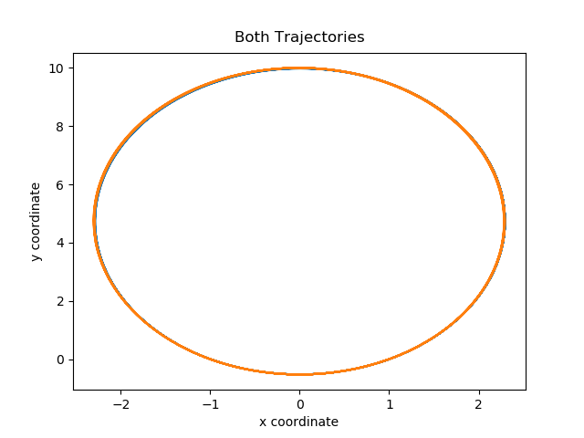
4. 4th order Runge-Kutta algorithm and the 4th order Forest-Ruth algorithm errors combined into one graph:
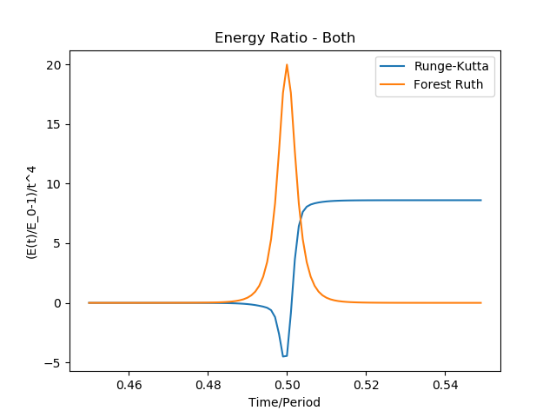

5. Comparing the rotation of the Laplace-Runge-Lenz vector for Runge-Kutta and Forest Ruth
